Ticket: IM9733397
Fixed Asset test case:
Discerption:
The Cigna Fixed Asset report is not correct for certain FEB-17 assets. Total depreciation and YTD depreciation is incorrect. The data appears to be in the database, but it is not presenting in the report - now showing on the expected prime. Appears to have prime join issues.

RPD changes:
Add a new column to “CORE” Fact - Fins - Asset Balance right click on table and select logical column
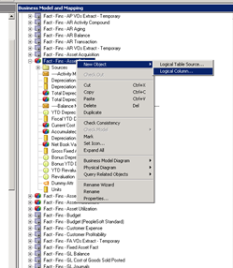
Give the column name as Total Depreciation amount YTD.
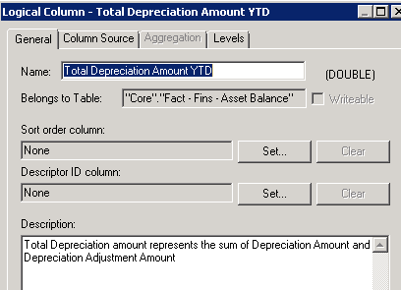
And Place the below expression in column mapping and click OK and SAVE.
ToDate("Core"."Fact - Fins - Asset Balance"."Total Depreciation Amount" , "Core"."Date - Fiscal Calendar"."Fiscal Year" )
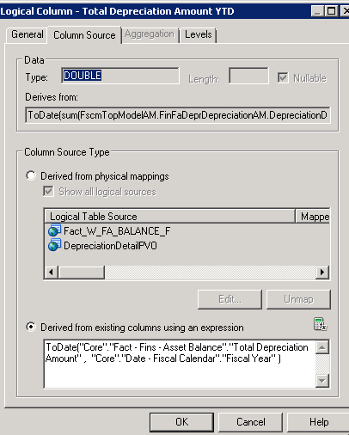
Drag and Drop the newly created column to Financials - Asset Overview → Facts - Asset Balance and Save.
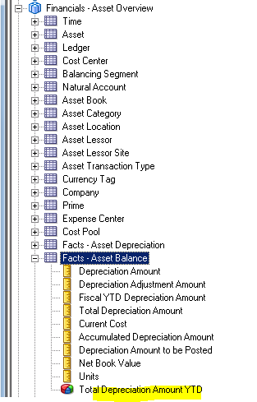
Catalog Chnages:
Goto Dashboard and select Cigna Custom Financials→Cigna Fixed Asset
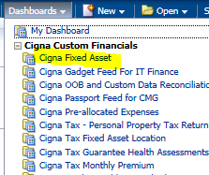

Delete below two columns form existing report.
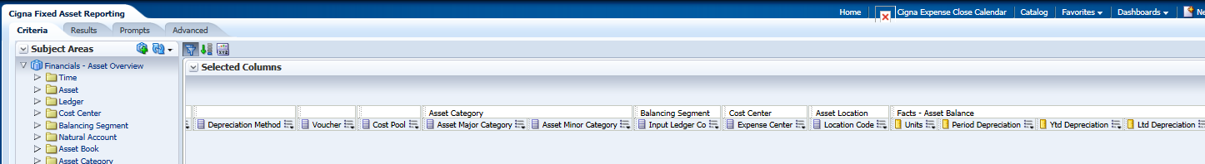
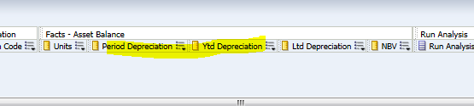
Add Below two columns from Facts-Asset Balance
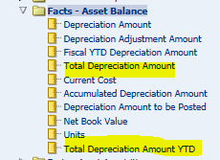
And rename total deprecation amount with Period Depreciation
Rename Total Depreciation amount YTD with YTD Depreciation
Test Results:
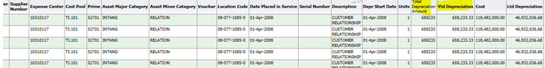

---------------------------------------------End Of Document-----------------------------------------

